All essays must use the following highlighting/revision marks & colors below! No exceptions!!!!
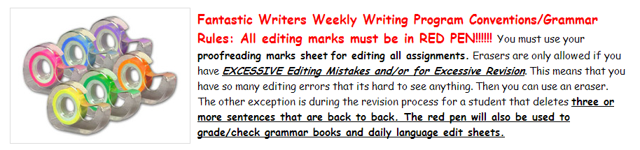
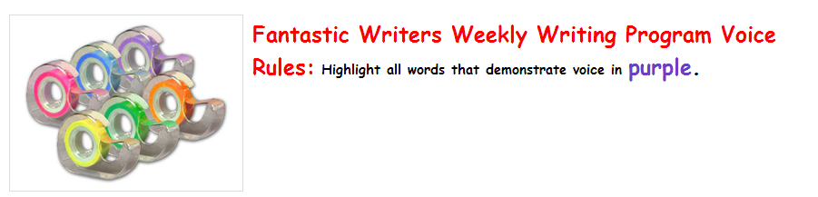

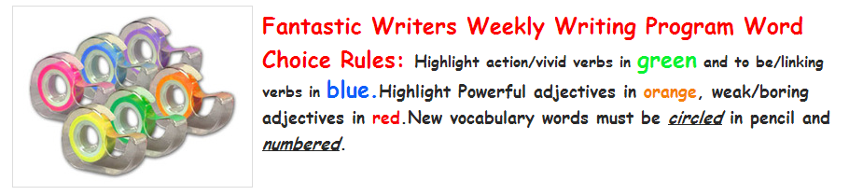

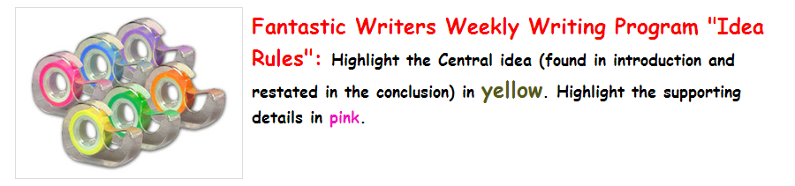
Notes: Don’t forget the paragraph ¶ symbol must be used to begin each new paragraph!

You must use the revision symbols on the back also!!!!!

